ARCHITECTURE AND IMPLEMENTATION REPORT
DeployGuard Railway-Like
Two-Lane PaaS Architecture
One-click deployment for developers, fast releases for every push, and Terraform only for genuine infrastructure changes

Version 2.0 | July 2026
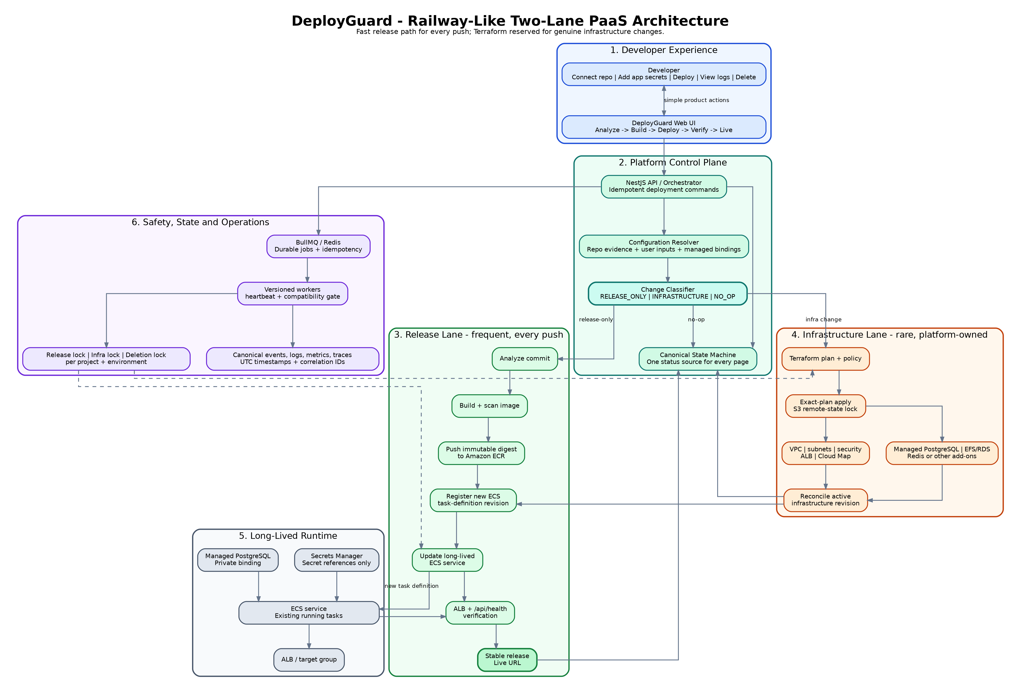
Figure 1. Target DeployGuard architecture with separate release and infrastructure lanes.
Core product promise
A developer connects a repository, supplies only unresolved application-owned values, clicks Deploy, and receives a live URL. Terraform, ECS, networking, cloud state, retries, and cleanup remain platform-owned.

1. Executive Summary
DeployGuard should operate as a Railway-like platform rather than a visible Terraform workflow. The central architectural decision is to split deployment into two internal lanes: a frequent release lane for ordinary code pushes and a rare infrastructure lane for genuine cloud topology changes. Both lanes converge on a long-lived ECS service, but only the infrastructure lane uses Terraform.
Architecture decision
Do not run Terraform for every commit. A normal release builds an image, pushes it to ECR, registers a new task-definition revision, updates the existing ECS service, verifies health, and promotes the release. Terraform runs only when the desired infrastructure changes.

Expected outcome
- Code pushes become fast and predictable because they avoid full infrastructure planning and state locking.
- Frequent builds may run concurrently, while release promotion is serialized per project and environment.
- The developer never sees Terraform plans, state refreshes, residue, ECS task definitions, Cloud Map, or cleanup internals.
- Infrastructure remains safely managed through an exclusive infrastructure lane with exact-plan identity and remote-state locking.
- All pages consume one canonical deployment state, preventing contradictory statuses and false recovery actions.

2. Design Goals and Non-Goals

Primary goals
- One-click deployment for a developer with zero cloud or DevOps experience.
- Fast release path for normal code changes.
- Deterministic classification of release-only, infrastructure, and no-op changes.
- Safe concurrency: parallel builds, one release promotion, one infrastructure mutation.
- Automatic recovery for platform-owned failures.
- One-click project deletion with durable progress and backend verification.
- Consistent status, progress, timestamps, and actions across the entire UI.

Explicit non-goals
- Exposing Terraform or AWS operations to the normal developer.
- Requiring users to approve technical infrastructure plans for ordinary deployment.
- Using stage count as user-facing progress.
- Allowing independent UI pages to infer status from partial events.
- Treating a build artifact as proof that current infrastructure and runtime configuration are valid.

3. Developer Experience Model
Connect repository | → | Add app values | → | Deploy | → | View status | → | Live URL

The normal developer experience contains no plan generation, infrastructure approval, state refresh, residue cleanup, selective stage recovery, or AWS resource navigation. DeployGuard performs those operations internally and exposes only actions the developer can understand.
Developer action | Platform responsibility | Developer sees
Connect repository | Authenticate GitHub, inspect repository, identify branch and commit | Repository connected
Provide missing values | Request only unresolved application-owned configuration; generate managed bindings | JWT_SECRET or another app-owned input
Deploy | Classify change, build, provision when needed, release, verify | Analyzing, Building, Deploying, Verifying
Redeploy | Reuse infrastructure; create a new release candidate | New deployment in progress
Delete project | Block new work, destroy scoped resources, verify, archive | Clear deletion progress

Developer boundary
A platform-owned error must never become a Terraform instruction for the developer. The user may be asked to fix application code or supply an application-owned value, but never to refresh state, unlock Terraform, inspect an ARN, or clean residue.

4. Logical Architecture
The platform is organized into six responsibilities: developer experience, platform control plane, release lane, infrastructure lane, long-lived runtime, and safety/operations. The Change Classifier is the routing decision between the two execution lanes.
Figure 2. Logical architecture and convergence on the long-lived ECS service.
Component | Responsibility | Key invariant
NestJS API / Orchestrator | Accept idempotent deployment, redeploy, and delete commands | Duplicate requests return the existing operation
Configuration Resolver | Combine repository evidence, developer input, and managed service bindings | Same semantic input produces the same normalized configuration
Change Classifier | Route to release-only, infrastructure, or no-op | Developer never chooses a lane
Canonical State Machine | Produce one authoritative status for every page | No page independently infers deployment state
BullMQ / Workers | Execute durable jobs and retries | Only compatible worker versions process jobs
Release Lane | Build and promote application revisions | No Terraform for normal code pushes
Infrastructure Lane | Create or modify cloud topology | Exact-plan apply under infrastructure lock
Long-Lived Runtime | Run the current stable task-definition revision | Infrastructure persists across releases
Reconciler | Compare intended state, Terraform state, AWS state, and runtime health | Uncertainty is displayed as verifying, not a false confident status

5. Change Classifier
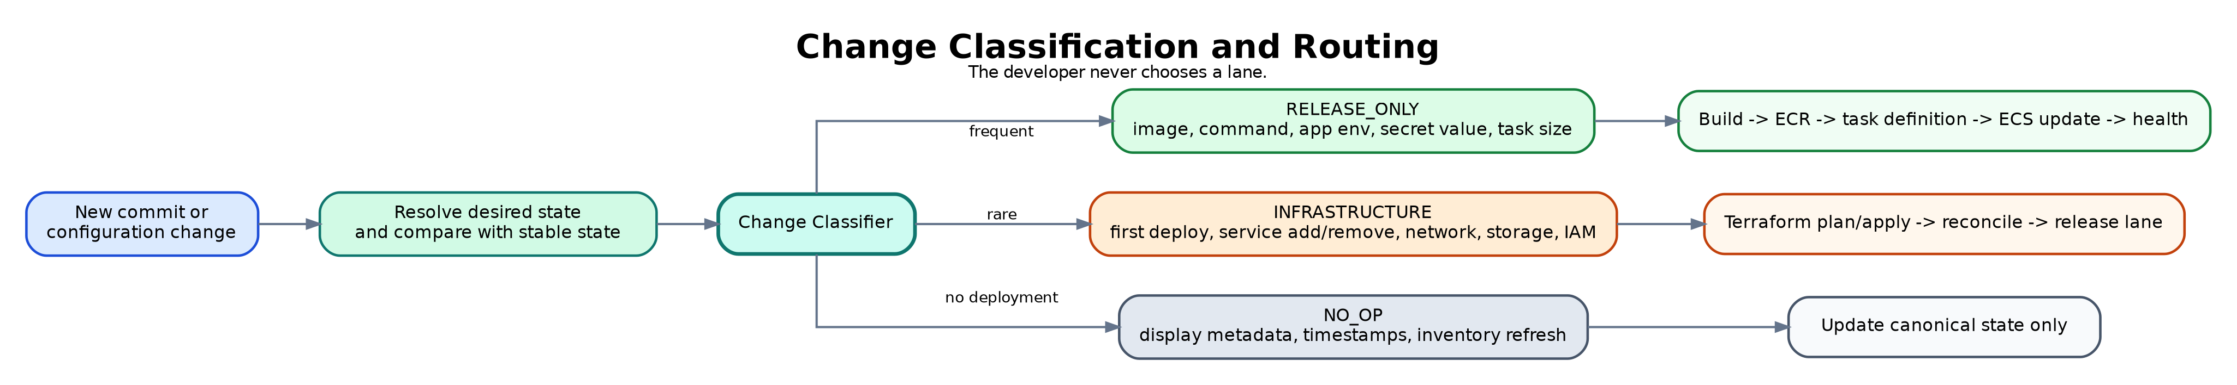
Figure 3. Automatic routing of each change.
The classifier compares the new desired state with the last stable infrastructure and release revisions. It must use normalized semantic values, not timestamps, database row order, activity events, health observations, or other volatile metadata.
Change example | Lane | Reason
Application source or Docker image | Release-only | Produces a new image and task-definition revision
Application command or start command | Release-only | Task-definition configuration only
Existing environment or secret value changed | Release-only | Update secret version or task-definition runtime reference
CPU or memory within existing ECS model | Release-only | New task-definition revision
Port or health path with no ALB structural change | Release-only | Task definition and target-group runtime settings only if supported safely
First deployment | Infrastructure | Cloud resources do not yet exist
Add or remove PostgreSQL, Redis, storage, or another service | Infrastructure | Creates or removes managed resources and bindings
VPC, subnet, security group, ALB listener, TLS, domain, IAM structure | Infrastructure | Changes cloud topology or policy
Database class, storage, backup policy, region | Infrastructure | Changes persistent infrastructure
Project display name, description, UI preference, notification setting | No-op | Does not affect deployment
Inventory refresh, health observation, timestamps, audit writes | No-op | Operational evidence only

Classifier output contract
The classifier should return lane, reasons, affected revision domains, required locks, whether a new plan is needed, whether the current image can be reused, and whether the active release remains valid.

6. Release Lane - Every Push
Git push | → | Analyze | → | Build + scan | → | Push ECR | → | Task revision | → | ECS update | → | Health | → | Live

The release lane is the default path for normal development. It reuses long-lived infrastructure and changes only the application release identity.

Release sequence
1. Create an immutable release candidate for the new commit.
2. Analyze the repository and resolve current application-owned runtime requirements.
3. Build the container image, scan it, and push an immutable digest to ECR.
4. Render and validate a new ECS task-definition revision from the active infrastructure revision and release configuration.
5. Acquire the release lock for project and environment.
6. Update the long-lived ECS service to the exact new task-definition revision.
7. Wait for ECS rollout, ALB target health, and application health endpoint success.
8. Mark the release stable and update the live URL/status.

Release-lane invariants
- Terraform is not initialized, planned, or applied for a release-only change.
- Multiple commits may build concurrently, but only one release promotion may update the ECS service at a time.
- The newest successful valid build becomes the deployment candidate; superseded builds remain historical.
- A release references the exact infrastructure revision it expects.
- A failed health check preserves the infrastructure and previous stable release.
- Rollback means repointing the ECS service to a previously stable task-definition revision.

7. Infrastructure Lane - Rare Changes
Classify infra | → | Terraform plan | → | Policy | → | Exact apply | → | Reconcile | → | Release lane

Terraform remains the infrastructure source of truth, but it is reserved for first deployment and genuine infrastructure changes. The lane is internal to DeployGuard and is not a developer workflow.

Infrastructure sequence
1. Acquire the infrastructure lock for the project and environment.
2. Freeze the infrastructure desired-state revision and generate run-isolated Terraform inputs.
3. Create a saved Terraform plan using the stable remote-state key.
4. Evaluate policy, cost limits, persistent-resource impact, and destructive changes internally.
5. Apply the exact verified plan once under the S3 remote-state lock.
6. Reconcile Terraform state with observed AWS resources and managed-service readiness.
7. Publish the new active infrastructure revision.
8. Regenerate the newest valid release manifest against that revision and continue through the release lane.
Database abstraction
The developer-facing contract should say Managed PostgreSQL. The current implementation may use PostgreSQL on ECS with encrypted EFS, while a later edition may use RDS. That implementation decision must not change the normal developer experience.

8. Concurrency, Locks, and Workspace Isolation
Operation | Concurrency policy | Lock / isolation
Repository analysis and image builds | Parallel across commits and projects | Unique build/release candidate ID
Release promotion | One per project and environment | release-lock:<projectId>:<environment>
Infrastructure plan/apply | One per project and environment | infra-lock:<projectId>:<environment> plus S3 lockfile
Project deletion | Exclusive; blocks deploy and release | delete-lock:<projectId>
Local Terraform files | Never shared across runs | /workspaces/<project>/<environment>/<operationId>/
Remote Terraform state | One stable state per project environment | projects/<projectId>/<environment>/terraform.tfstate

Lock relationship
- An infrastructure apply blocks release promotion because the runtime manifest may depend on the resulting infrastructure revision.
- A release-only operation does not acquire the Terraform state lock.
- When a newer release arrives during infrastructure apply, it waits, then regenerates against the reconciled infrastructure revision.
- When a newer commit arrives during an older release build, both may finish building; only the newest valid candidate is promoted.
- Deletion acquires the highest-level project lock, blocks new work, cancels queued operations, and reconciles any in-flight mutation before destruction.

Idempotency keys
Recommended operation identities
build:<releaseId> | release:<releaseId>:<taskFingerprint> | infra:<infraRevision>:<planFingerprint> | delete:<projectId>:<deletionRequestId>

9. Revision and Fingerprint Model
A single fingerprint for every concern creates false staleness. DeployGuard should maintain independent semantic revision domains and explicit relationships between them.
Revision / fingerprint | Contains | Does not contain
infrastructureRevision | Network, managed services, storage, IAM, ALB structure, secret resource identities | Health status, timestamps, inventory refresh, application image
releaseRevision | Image digest, command, port, health path, task size, app environment and secret references | VPC topology, database class, operational timestamps
contractFingerprint | Normalized effective deployment contract for the operation | GeneratedAt, row order, status text, progress, event timestamps
terraformInputFingerprint | Exact normalized Terraform variable content | Plan creation timestamp or approval metadata
planFingerprint | Exact plan identity and artifact hash relationships | Unrelated current-state observations
taskDefinitionFingerprint | Canonical container definition, environment destinations, secret references, image digest | ECS rollout status and ALB observations

Release relationship
Each stable release records releaseRevision, infrastructureRevision, imageDigest, taskDefinitionRevision, health evidence, and promotion time. Before promotion, DeployGuard verifies that the referenced infrastructure revision is still active.

10. Canonical State, Events, and Time
All developer-facing pages must use one canonical backend projection. The frontend renders state; it does not calculate state from partial events.
Canonical field | Purpose
projectStatus | High-level project lifecycle: deploying, live, failed, deleting, deleted
deploymentId / operationId | Exact active operation identity
phase | Analyze, Build, Prepare, Deploy, Verify, Live
progress | Monotonic weighted progress
userActionRequired | Whether the developer must supply an app-owned value or fix application code
errorOwner | developer, platform, cloud-provider, or unverified
lastVerifiedAt | Freshness of cloud/runtime evidence
activeInfrastructureRevision | Current cloud topology identity
activeReleaseRevision | Current stable application release identity
nextSafeAction | Simple developer action or internal automatic action

Event model
- Store authoritative event time in PostgreSQL timestamptz / UTC.
- Assign a monotonic sequence number per operation so ordering does not depend on clock skew.
- Persist startedAt, finishedAt, and durationMs once in the backend.
- Correlate projectId, environment, operationId, workerId, stage, attempt, Terraform operation, and AWS operation.
- Use explicit QUEUED, STARTED, COMPLETED, FAILED, SKIPPED, and BLOCKED events. Lock release is not deployment success.

11. Worker and Queue Safety
- Every worker registers workerId, applicationVersion, gitCommitSHA, schemaVersion, startedAt, and heartbeatAt.
- The queue dispatcher rejects workers whose code/schema version is incompatible with the current backend requirement.
- Duplicate BullMQ delivery re-enters the same idempotent operation rather than creating another apply or release.
- A worker restart restores the operation from durable checkpoints and does not regenerate a different plan or contract.
- Stale worker detection is automatic; restarting a terminal is not a developer responsibility.
User-facing stale-worker message
DeployGuard is updating its deployment service. Your deployment will resume automatically.

12. Error Ownership and Automatic Recovery
Owner | Examples | Developer message | Platform response
Developer | Missing app secret, build error, invalid start command, app not listening, failing application health | Your application needs attention. | Show exact app-owned fix and preserve infrastructure
DeployGuard platform | Fingerprint mismatch, stale worker, queue duplication, state-lock or classifier defect | DeployGuard encountered an internal deployment issue. No action is required from you. | Retry/reconcile automatically; alert admin
Cloud provider | Quota, throttling, regional service issue | AWS is temporarily preventing this deployment. DeployGuard will retry. | Backoff, retry, and preserve active release
Unverified | Database, Terraform state, AWS state, and UI disagree | DeployGuard is verifying deployment status. | Run reconciliation before presenting a confident state

Recovery behavior
- Build failure: fail the release candidate; no infrastructure action.
- Release rollout failure: retain or restore the previous stable task definition.
- Application health failure: preserve infrastructure and surface application evidence.
- Infrastructure plan failure: no cloud mutation; correct internal configuration or report platform failure.
- Partial infrastructure apply: reconcile state and AWS before any new plan; never automatically destroy.
- Managed-service readiness failure: preserve resources and retry the managed service or binding internally.
- Repeated self-invalidating runs: stop automatic regeneration and raise a platform incident rather than creating an infinite run loop.

13. Security and Secret Handling
- Application-owned secrets are stored in Secrets Manager and referenced from ECS task definitions, never placed in ordinary environment output.
- Managed database credentials are platform-owned and cannot be overridden by historical user values.
- DB_PASSWORD and JWT_SECRET are rendered only through ECS secrets.
- DB_HOST, DB_PORT, DB_NAME, and policy-approved non-sensitive values are rendered through ECS environment entries.
- DATABASE_URL is included only when current repository source evidence proves it is used.
- No key may appear in both environment and secrets.
- Logs, events, activity records, plan summaries, and APIs expose only allowlisted metadata and sanitized reason codes.

14. One-Click Deletion
Delete project | → | Block work | → | Reconcile | → | Destroy internally | → | Verify AWS | → | Archive

Deletion is a durable backend operation, not a multi-page technical workflow. The user confirms once and then sees a persistent progress screen that survives refresh and worker restart.
Step | Backend behavior | Developer-facing text
1. Block | Disable new deploy/release operations and cancel queued candidates | Stopping deployments
2. Reconcile | Wait for or reconcile an active release or infrastructure mutation | Preparing safe deletion
3. Destroy | Generate and apply the project-scoped destroy operation internally | Removing application and database resources
4. Verify | Compare Terraform state and AWS observed resources; classify remaining records | Verifying cloud removal
5. Archive | Mark project deleted and retain read-only audit evidence | Project deleted

Authentication UX
A recent valid session should be enough for normal deletion. When step-up authentication is required, return the user directly to the same deletion confirmation and continue with a short-lived, single-use action token.

15. Developer UI Information Architecture

Normal developer navigation
Page | Purpose
Dashboard | Projects, high-level status, recent deployments
Project Overview | Current status, live URL, latest release, one Deploy/Redeploy action
Deployments | Simple deployment history and five user-facing phases
Environment Variables | Application-owned values only; platform-managed bindings are read-only summaries
Logs | Application logs and concise deployment messages
Metrics | Application availability, response time, CPU, memory
Settings | Repository, branch, domain, deletion

Admin-only diagnostics
- Terraform plan/apply evidence and state serials
- Cloud inventory and ownership reconciliation
- Worker versions, heartbeats, queue jobs, retries, and dead-letter evidence
- Detailed 20-stage lifecycle and sanitized technical events
- Resource cleanup, unknown ownership, lock evidence, and deletion diagnostics
- State-proof endpoint showing synchronized, stale, contradictory, or unverified status

User-facing progress
Analyze 0-15% | → | Build 15-40% | → | Prepare 40-60% | → | Deploy 60-90% | → | Verify 90-100% | → | Live

- Progress never moves backward.
- Internal safety revalidation does not return the UI to Validate inputs.
- A queued stage is not displayed as running.
- A failed operation freezes at the actual phase and shows the error owner.
- A resumed operation displays Resuming deployment instead of presenting a new deployment identity unless a new immutable operation is truly required.

16. Observability and Reconciliation
- Collect structured logs, metrics, and traces for the DeployGuard platform itself, not only for deployed applications.
- Measure queue delay, build duration, lock wait, plan duration, apply duration, rollout duration, health verification, retries, and reconciliation differences.
- Use a background reconciler to compare database intended state, active operations, Terraform state, AWS observed state, ECS rollout, ALB target health, and application health.
- When evidence is stale, show Checking deployment status instead of a potentially false live or failed status.
- Reduce Activity Log noise: aggregate resource discovery into one meaningful event for developers and retain detailed records in admin diagnostics.

17. Implementation Roadmap
Phase | Scope | Exit condition
1. Stabilize control plane | Freeze broken deploy/recovery actions; create canonical state and state-proof endpoint | All pages display one consistent operation and status
2. Introduce classifier and revision domains | Implement releaseRevision, infrastructureRevision, semantic diffs, and no-op routing | Unchanged input never creates a plan; ordinary pushes route to release lane
3. Build release lane | ECR digest, task definition, release lock, ECS rollout, health, rollback | Five consecutive release-only deployments without Terraform
4. Harden infrastructure lane | Run-isolated Terraform workspace, infra lock, exact-plan apply, reconciliation | First deploy and one managed-service change succeed without duplicate mutation
5. Worker and concurrency safety | Version compatibility, heartbeat, idempotency, duplicate delivery, restart recovery | Concurrent builds and worker restarts do not duplicate apply or release
6. Simplify developer UI | Five phases, error ownership, admin separation, monotonic progress | No Terraform/DevOps instructions visible to normal users
7. One-click deletion | Durable deletion operation, progress, verification, archive | Two disposable projects delete successfully from one confirmation
8. Operational proof | Real AWS concurrency, transient failure, health failure, partial apply, deletion recovery | Release criteria below are met

18. Acceptance and Release Criteria
Scenario | Required result
Five consecutive code pushes | No Terraform; each creates one release candidate and at most one ECS promotion
Two same-project commits pushed quickly | Builds may overlap; newest valid release wins; no duplicate ECS promotion
New commit during infrastructure apply | Release waits, regenerates against reconciled infrastructure, then promotes
Duplicate queue delivery | Same idempotent operation resumes; executor invoked at most once
Worker restart after build / before promotion | Operation resumes with same release identity
Worker version mismatch | Job is not processed by stale worker; developer sees automatic service update message
Application health failure | Previous stable release remains available; no Terraform or cleanup instruction
Platform-owned failure | Developer receives no cloud instruction; admin receives correlated diagnostic evidence
Managed service addition | One infrastructure plan/apply, then release lane; no duplicate project stack
Project deletion | One confirmation, durable progress, zero active project infrastructure, archived record
Cross-page consistency | Dashboard, Overview, Deployments, Logs, Recovery/Admin show the same operation, phase, owner, and timestamp basis

Operational success statement
DeployGuard is ready for a Railway-like developer experience only when ordinary pushes consistently bypass Terraform, infrastructure changes are safely serialized, releases converge on a long-lived ECS service, deletion is one clear backend operation, and every page reflects the same canonical state.

19. Final Recommendation
Adopt the two-lane architecture as the new DeployGuard baseline. Keep Terraform as the authoritative infrastructure engine, but remove it from the normal release path and the normal developer interface. Make the Change Classifier, independent revision domains, canonical state projection, release and infrastructure locks, worker compatibility, and one-click deletion the core platform capabilities.
- Default path: build image, register task-definition revision, update ECS service, verify health.
- Rare path: Terraform plan/apply only for first deployment and genuine infrastructure changes.
- Developer experience: one Deploy button, one clear status, one live URL, one Delete action.
- Administrator experience: detailed cloud, Terraform, queue, state, and reconciliation evidence.
- Release gate: prove repeated real deployments and deletions, not only unit tests or completion reports.
Prepared for DeployGuard architecture refinement and implementation planning

